Lecture 8: SHA-256

LEARNING OUTCOME
By the end of the lesson the student will be able to:
- understand a concept of a hashing function
- compute a set of 32-bit operation on a secure hashing function
- compute one round of SHA-256

The SHA-256 compression function operates on a 512-bit message block and a 256-bit intermediate hash value. It is essentially a 256-bit block cipher algorithm which encrypts the intermediate hash value using the message block as key.

Consider the following notation of the 7 operations in Secure Hashing Algorithm SHA-2:

Symbol | Operation
⊕ | Bitwise XOR
∧ | Bitwise AND
∨ | Bitwise OR
¬ | Bitwise complement
+ | Mod 2³² addition
R^{n} | Right shift by n bits
S^{n} | Right rotation by n bits

Table 1: Notations on 32-bit operations

All of these operators act on 32-bit words. Unsigned long is popular programming variable in the year 2000 onwards.

0. The initial hash value H⁽⁰⁾ is the following sequence of 32-bit words. They are obtained by taking the fractional parts of the square roots of the first eight primes):

H₁ ⁽⁰⁾ = 6A09E667
H₂ ⁽⁰⁾ = BB67AE85
H₃ ⁽⁰⁾ = 3C6EF372
H₄ ⁽⁰⁾ = A54FF53A
H₅ ⁽⁰⁾ = 510E527F
H₆ ⁽⁰⁾ = 9B05688C
H₇ ⁽⁰⁾ = 1F83D9AB
H₈ ⁽⁰⁾ = 5BE0CD19

1. In a standard document, SHA-2 will hash a string “abc”. Pad the message in the usual way: Suppose the length of the message M, in bits, is L. Append the bit “1” to the end of the message, and then k zero bits, where k is the smallest non-negative solution to the equation L+1+k ≡ 448 mod 512. To this append the 64-bit block which is equal to the number written in binary. For example, the (8-bit ASCII) message “abc” has length 8 ⋅ 3 = 24 so it is padded with a one, then 448 – (24 + 1) = 423 zero bits, and then its length to become the 512-bit padded message

01100001 01100010 01100011 100 ⋅⋅⋅ ⋅⋅⋅ 00 00 ⋅⋅⋅ 011000
424 bits
64 bits

61 62 63 80 00 … 00 18₁₆ written in hexa decimals.

We need to form the first block.
The length of the padded message should now be a multiple of 512 bits.

2. Parse the message into N 512-bit message blocks M⁽¹⁾, M⁽²⁾, ……, M^{(N)}. In this case N= 1;
The first 32 bits of message block i are denoted M₀^{(i)}, the next 32 bits are M₁ ^{(i)}, and so on up to M₁₅ ^{(i)}. We use the little-endian convention throughout, so within each 32-bit word, the left-most bit is stored in the most significant bit position.
In this example, however, we will take M = ‘Nur Azman Abu SMS Muar’. L = 22⋅8 = 176 bits. Add another bit ‘1’ which will give us 8 in hexa.

M =
4E757220417A6D616E2041627520534D53204D75617280000000000000000000
00000000000000000000000000000000000000000000000000000000000000B0

M₀⁽⁰⁾ | 4E757220
M₁⁽⁰⁾ | 417A6D61
M₂⁽⁰⁾ | 6E204162
M₃⁽⁰⁾ | 7520534D
M₄⁽⁰⁾ | 53204D75
M₅⁽⁰⁾ | 61728000
M₆⁽⁰⁾ | 00000000
M₇⁽⁰⁾ | 00000000
M₈⁽⁰⁾ | 00000000
M₉⁽⁰⁾ | 00000000
M₁₀⁽⁰⁾ | 00000000
M₁₁⁽⁰⁾ | 00000000
M₁₂⁽⁰⁾ | 00000000
M₁₃⁽⁰⁾ | 00000000
M₁₄⁽⁰⁾ | 00000000
M₁₅⁽⁰⁾ | 000000B0

3. A sequence of constant 8×8 key words K are taken from the first thirty-two bits of the fractional parts of the cube roots of the first sixty-four primes.

K₀, K₁, K₂, K₃, …………………………...., K₇
K₈, ……………………………………..…., K₁₅
K₁₆, ……………………………………..…, K₂₃
K₂₄, ……………………………………..…, K₃₁
K₃₂, …………………………………..……, K₃₉
K₄₀, ……………………………………..…, K₄₇
K₄₈, …………………………………..……, K₅₅
K₅₆, K₅₇, K₅₈, ……………………………..., K₆₃

is being used in SHA-256. In hex, these are given by

428A2F98 | 71374491 | B5C0FBCF | E9B5DBA5 | 3956C25B | 59F111F1 | 923F82A4 | AB1C5ED5
D807AA98 | 12835B01 | 243185BE | 550C7DC3 | 72BE5D74 | 80DEB1FE | 9BDC06A7 | C19BF174
E49B69C1 | EFBE4786 | 0FC19DC6 | 240CA1CC | 2DE92C6F | 4A7484AA | 5CB0A9DC | 76F988DA
983E5152 | A831C66D | B00327C8 | BF597FC7 | C6E00BF3 | D5A79147 | 06CA6351 | 14292967
27B70A85 | 2E1B2138 | 4D2C6DFC | 53380D13 | 650A7354 | 766A0ABB | 81C2C92E | 92722C85
A2BFE8A1 | A81A664B | C24B8B70 | C76C51A3 | D192E819 | D6990624 | F40E3585 | 106AA070
19A4C116 | 1E376C08 | 2748774C | 34B0BCB5 | 391C0CB3 | 4ED8AA4A | 5B9CCA4F | 682E6FF3
748F82EE | 78A5636F | 84C87814 | 8CC70208 | 90BEFFFA | A4506CEB | BEF9A3F7 | C67178F2

4. Check the value the first thirty-two bits of the fractional parts of the cube roots of the first 8 primes. For instance, 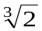 = 1.2599210498948731647672106072782.

.i | K_{i} |  |  |  |  |  |  |  |  |  |  | Base
0 |  | 1 | . | 259 | 921 | 049 | 894 | 873 | 164 | 767 | 210 | ₁₀
 |  | 1 | . | 0100 | 0010 | 1000 | 1010 | 0010 | 1111 | 1001 | 1000 | ₂
 |  |  | . | 4 | 2 | 8 | A | 2 | F | 9 | 8 | ₁₆
1 | 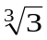 | 1 | . | 442 | 249 | 570 | 307 | 408 | 382 | 321 | 638 | ₁₀
 |  | 1 | . | 0111 | 0001 | 0011 | 0111 | 0100 | 0100 | 1001 | 0001 | ₂
 |  |  | . | 7 | 1 | 3 | 7 | 4 | 4 | 9 | 1 | ₁₆
2 | 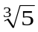 | 1 | . | 709 | 975 | 946 | 676 | 696 | 989 | 353 | 108 | ₁₀
 |  | 1 | . | 1011 | 0101 | 1100 | 0000 | 1111 | 1011 | 1100 | 1111 | ₂
 |  |  | . | B | 5 | C | 0 | F | B | C | F | ₁₆
3 | 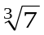 | 1 | . | 912 | 931 | 182 | 772 | 389 | 101 | 199 | 116 | ₁₀
 |  | 1 | . | 1110 | 1001 | 1011 | 0101 | 1101 | 1011 | 1010 | 0101 | ₂
 |  |  | . | E | 9 | B | 5 | D | B | A | 5 | ₁₆
4 | 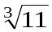 | 2 | . | 223 | 980 | 090 | 569 | 315 | 521 | 165 | 363 | ₁₀
 |  | 10 | . | 0011 | 1001 | 0101 | 0110 | 1100 | 0010 | 0101 | 1011 | ₂
 |  |  | . | 3 | 9 | 5 | 6 | C | 2 | 5 | B | ₁₆
5 | 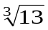 | 2 | . | 351 | 334 | 687 | 720 | 757 | 489 | 500 | 16 | ₁₀
 |  | 10 | . | 0101 | 1001 | 1111 | 0001 | 0001 | 0001 | 1111 | 0001 | ₂
 |  |  | . | 5 | 9 | F | 1 | 1 | 1 | F | 1 | ₁₆
6 | 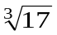 | 2 | . | 571 | 281 | 590 | 658 | 235 | 355 | 453 | 187 | ₁₀
 |  | 10 | . | 1001 | 0010 | 0011 | 1111 | 1000 | 0010 | 1010 | 0100 | ₂
 |  |  | . | 9 | 2 | 3 | F | 8 | 2 | A | 4 | ₁₆
7 | 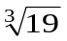 | 2 | . | 668 | 401 | 648 | 721 | 944 | 867 | 339 | 627 | ₁₀
 |  | 10 | . | 1010 | 1011 | 0001 | 1100 | 0101 | 1110 | 1101 | 0101 | ₂
 |  |  | . | A | B | 1 | C | 5 | E | D | 5 | ₁₆

5. Six logical functions are used in SHA-256. Each of these functions operates on 32-bit words and produces a 32-bit word as output. Each function is defined as
follows:
λ(x, y, z) = (x ^ y) ⊕ (¬x ^ z)
μ(x, y, z) = (x ^ y) ⊕ (x ^ z) ⊕ (y ^ z)
Σ₀(x) = S²(x) ⊕ S¹³(x) ⊕ S²²(x)
Σ₁(x) = S⁶(x) ⊕ S¹¹(x) ⊕ S²⁵(x)
σ₀(x) = S⁷(x) ⊕ S¹⁸(x) ⊕ R³(x)
σ₁(x) = S¹⁷(x) ⊕ S¹⁹(x) ⊕ R¹⁰(x)

Symbol | Operation
⊕ | Bitwise XOR
∧ | Bitwise AND
∨ | Bitwise OR
¬ | Bitwise complement
+ | Mod 2³² addition
R^{n} | Right shift by n bits
S^{n} | Right rotation by n bits

Table 1: Notations on 32-bit operations

Expanded message blocks W₀, W₁, W₂, W₃, …., W₆₃ are computed as follows via the SHA-256 message schedule: In this tutorial we will do only one round for j = 0, 1, 2, …, 31 on a 512-bit block.

for j = 0, 1, …, 15
W_{j} = M_{j}^{(i)}

W₀ | = | M₀⁽⁰⁾ | = | 4E757220
W₁ | = | M₁⁽⁰⁾ | = | 417A6D61
W₂ | = | M₂⁽⁰⁾ | = | 6E204162
W₃ | = | M₃⁽⁰⁾ | = | 7520534D
W₄ | = | M₄⁽⁰⁾ | = | 53204D75
W₅ | = | M₅⁽⁰⁾ | = | 61728000
W₆ | = | M₆⁽⁰⁾ | = | 00000000
W₇ | = | M₇⁽⁰⁾ | = | 00000000
W₈ | = | M₈⁽⁰⁾ | = | 00000000
W₉ | = | M₉⁽⁰⁾ | = | 00000000
W₁₀ | = | M₁₀⁽⁰⁾ | = | 00000000
W₁₁ | = | M₁₁⁽⁰⁾ | = | 00000000
W₁₂ | = | M₁₂⁽⁰⁾ | = | 00000000
W₁₃ | = | M₁₃⁽⁰⁾ | = | 00000000
W₁₄ | = | M₁₄⁽⁰⁾ | = | 00000000
W₁₅ | = | M₁₅⁽⁰⁾ | = | 000000B0

for j = 16 to 63
{
W_{j} = σ₁(W_{j–2}) +W_{j–7} + σ₀(W_{j–15}) +W_{j–16}
}

6. Initialize the value of the 32-bit registers a, b, c, d, e, f, g, h for i =1st 512-bit block.

From H₁ ⁽⁰⁾ = 6A09E667
H₂ ⁽⁰⁾ = BB67AE85
H₃ ⁽⁰⁾ = 3C6EF372
H₄ ⁽⁰⁾ = A54FF53A
H₅ ⁽⁰⁾ = 510E527F
H₆ ⁽⁰⁾ = 9B05688C
H₇ ⁽⁰⁾ = 1F83D9AB
H₈ ⁽⁰⁾ = 5BE0CD19

a | = | H₁^{(i–1)} | = | 6A09E667
b | = | H₂^{(i–1)} | = | BB67AE85
c | = | H₃^{(i–1)} | = | 3C6EF372
d | = | H₄^{(i–1)} | = | A54FF53A
e | = | H₅^{(i–1)} | = | 510E527F
f | = | H₆^{(i–1)} | = | 9B05688C
g | = | H₇^{(i–1)} | = | 1F83D9AB
h | = | H₈^{(i–1)} | = | 5BE0CD19

7. Apply the SHA-256 compression function to update registers a, b, c, d, e, f, g, h,
In this tutorial we will do only one round for j = 0.

for j = 0 to 63 do
{
\\Compute λ(e, f, g), μ(a, b, c), Σ₀(a), Σ₁(e), and W_{j}
\\see Definitions of the 5 logical functions above.

T₁ = h + Σ₁(e) + λ(e, f, g) + K_{j} + W_{j}

T₂ = Σ₀(a) + μ(a, b, c)

h = g
g = f
f = e
e = d + T₁
d = c
c = b
b = a
a = T₁ + T₂
}

Symbol | Operation
⊕ | Bitwise XOR
∧ | Bitwise AND
∨ | Bitwise OR
¬ | Bitwise complement
+ | Mod 2³² addition
R^{n} | Right shift by n bits
S^{n} | Right rotation by n bits

Table 1: Notations on 32-bit operations

Let us compute T₁ = h + Σ₁(e) + λ(e, f, g) + K_{j} + W_{j},
First, we need to compute Σ₁(e)
where Σ₁(x) = S⁶(x) ⊕ S¹¹(x) ⊕ S²⁵(x)

Σ₁(e) = Σ₁(510E527F) = ?

S⁶(e) = S⁶(510E527F) = FD443949
01010001000011100101001001111111
01010001000011100101001001111111
11111101010001000011100101001001
1111 1101 0100 0100 0011 1001 0100 1001

S¹¹(e) = S¹¹(510E527F) = 4FEA21CA
01010001000011100101001001111111
01001111111010100010000111001010
0100 1111 1110 1010 0010 0001 1100 1010

S²⁵(e) = S²⁵(510E527F) = 87293FA8
01010001000011100101001001111111
10000111001010010011111110101000
1000 0111 0010 1001 0011 1111 1010 1000

Σ₁(510E527F) = S⁶(510E527F) ⊕ S¹¹(510E527F) ⊕ S²⁵(510E527F)
= FD443949 ⊕ 4FEA21CA ⊕ 87293FA8
= 3587272B

Second, we need to compute λ(e, f, g)
where
λ(x, y, z) = (x ^ y) ⊕ (¬x ^ z)
λ(e, f, g) = λ(510E527F, 9B05688C, 1F83D9AB)
= (510E527F^9B05688C)⊕( ¬510E527F^1F83D9AB)
= 1104400C ⊕ 0E818980
= 1F85C98C

Note:¬510E527F = AEF1 AD80

Coming back to compute

T₁ = h + Σ₁(e) + λ(e, f, g) + K₀ + W₀,

= 5BE0CD19 + 3587272B + 00061027 + 428A2F98 + 4E757220,
= 9167F444 + 00061027 + 90FFA1B8
= 1226DA623
= 226DA623 (mod 2³²)

Third, we need to compute T₂ = Σ₀(a) + μ(a, b, c)

Σ₀(a) = S²(a) ⊕ S¹³(a) ⊕ S²²(a) where a = 6A09E667
Σ₀(6A09E667) = S²(6A09E667) ⊕ S¹³(6A09E667) ⊕ S²²(6A09E667)

S²(6A09E667) = S²(01101010000010011110011001100111)
= 11011010100000100111100110011001
= 11011010100000100111100110011001
= DA827999

S¹³(6A09E667) = S¹³(01101010000010011110011001100111)
= S¹³( 01101010000010011110011001100111)
= 00110011001110110101000001001111
= 00110011001110110101000001001111
= 333B504F

S²²(6A09E667) = S²²(01101010000010011110011001100111)
= S²²(01101010000010011110011001100111)
= 00100111100110011001110110101000
= 00100111100110011001110110101000
= 27999DA8

Σ₀(6A09E667) = S²(6A09E667) ⊕ S¹³(6A09E667) ⊕ S²²(6A09E667)
= DA827999 + 333B504F + 27999DA8
= CE20B47E

μ(x, y, z) = (x ^ y) ⊕ (x ^ z) ⊕ (y ^ z)

μ(a, b, c) = (a ^ b) ⊕ (a ^ c) ⊕ (b ^ c)
= (6A09E667 ^ BB67AE85) ⊕ (6A09E667 ^ 3C6EF372) ⊕ (BB67AE85 ^ 3C6EF372)
= 2A01A605 ⊕ 2808E262 ⊕ 3866A200
= 3A6FE667‬

Fourth, we can compute T₂ = Σ₀(a) + μ(a, b, c)
= CE20B47E + 3A6FE667‬
= 108909AE5
= 08909AE5 (mod 2³²)

Lastly, from the previous values of registers a, b, c, d, e, f, g, h,

a | = | H₁^{(i–1)} | = | 6A09E667
b | = | H₂^{(i–1)} | = | BB67AE85
c | = | H₃^{(i–1)} | = | 3C6EF372
d | = | H₄^{(i–1)} | = | A54FF53A
e | = | H₅^{(i–1)} | = | 510E527F
f | = | H₆^{(i–1)} | = | 9B05688C
g | = | H₇^{(i–1)} | = | 1F83D9AB
h | = | H₈^{(i–1)} | = | 5BE0CD19

Update on the register to get ready to go to next round,

h = g = 1F83D9AB
g = f = 9B05688C
f = e = 510E527F
e = d + T₁ = A54FF53A + 226DA623 = C7BD9B5D
d = c = 3C6EF372
c = b = BB67AE85
b = a = 6A09E667
a = T₁ + T₂ = 226DA623 + 08909AE5 = 2AFE4108
Fill up the new values of the 32-bit registers after the first loop j = 0.

a | = | 2AFE4108
b | = | 6A09E667
c | = | BB67AE85
d | = | 3C6EF372
e | = | C7BD9B5D
f | = | 510E527F
g | = | 9B05688C
h | = | 1F83D9AB

Register: a | b | c | d | e | f | g | h
2AFE4108 | 6A09E667 | BB67AE85 | 3C6EF372 | C7BD9B5D | 510E527F | 9B05688C | 1F83D9AB
\\ After the full 64 loops, we may compute the i^{th} intermediate hash value H^{(i)}

H₁ ^{(i)} = a + H₁ ^{(i–1)}
H₂ ^{(i)} = b + H₂ ^{(i–1)}
H₃ ^{(i)} = c + H₃ ^{(i–1)}
H₄ ^{(i)} = d + H₄ ^{(i–1)}
H₅ ^{(i)} = e + H₅ ^{(i–1)}
H₆ ^{(i)} = f + H₆ ^{(i–1)}
H₇ ^{(i)} = g + H₇ ^{(i–1)}
H₈ ^{(i)} = h + H₈ ^{(i–1)}

At the end of the computation, Block 1 has been processed. The values of {H_{i}} are
a | = | 2AFE4108
b | = | 6A09E667
c | = | BB67AE85
d | = | 3C6EF372
e | = | C7BD9B5D
f | = | 510E527F
g | = | 9B05688C
h | = | 1F83D9AB

Finally,

H₁ = 2AFE4108+6A09E667 = 9508276F
H₂ = 6A09E667+BB67AE85 = 1257194EC
H₃ = BB67AE85+3C6EF372 = F7D6A1F7
H₄ = 3C6EF372+A54FF53A = E1BEE8AC
H₅ = C7BD9B5D+510E527F = 118CBEDDC
H₆ = 510E527F+9B05688C = EC13BB0B
H₇ = 9B05688C+1F83D9AB = BA894237
H₈ = 1F83D9AB+5BE0CD19 = 7B64A6C4.

The message digest is, at the moment, after the first round, ready for the next round j=1.
9508276F257194ECF7D6A1F7E1BEE8AC18CBEDDCEC13BB0BBA8942377B64A6C4.
Sample Midterm Question

Refer to Figure 2. Describe THREE(3) steps of signature verification (6 marks)

Sign_{D}(H(M))
Plaintext
M
Source A
Destination B
Hash
Private Key D
Plaintext
M
Hash
Public Key E
Compare
Sign
Verify

Figure 2: Basic Uses of Hash Functions: It shows the hash being signed with the sender’s private key, thus forming a digital signature.

In DES Challenge III was a joint effort between distributed.net and Deep Crack.
The key was found in just 22 hours 15 minutes in January 1999, and the plaintext
was "See you in Rome”. The DES cipher is considered breakable within a day.

However, in SHA2, if we can find 2 messages with the same hash value, we have just found a collision.
It is practically too naïve and far away to consider practical weakness in the hashing algorithm.

In order to conclude that SHA2 is a weak hash function we need to find 2 meaningful messages which collide into the same digest.

Birthday Paradox

LEARNING OUTCOME
By the end of this lesson a student will be able to:

- To gain a wisdom from a birthday paradox.
- To brute force a cryptosystem takes much less than total possibilities.

Let the first person has no one to share a birthday, the second person cannot have the same birthday as the first (364/365), the third cannot have the same birthday as either of the first two (363/365), and in general the n^{th} birthday cannot fall on the same as any of the n − 1 preceding birthdays. Suppose there are 10 persons. The probability no one shares the same birthday is
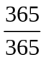⋅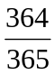⋅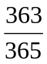⋅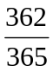⋅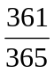⋅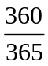⋅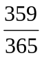⋅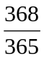⋅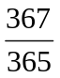⋅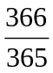
In real life, the probability is much higher due to non-uniformity of the birthday.
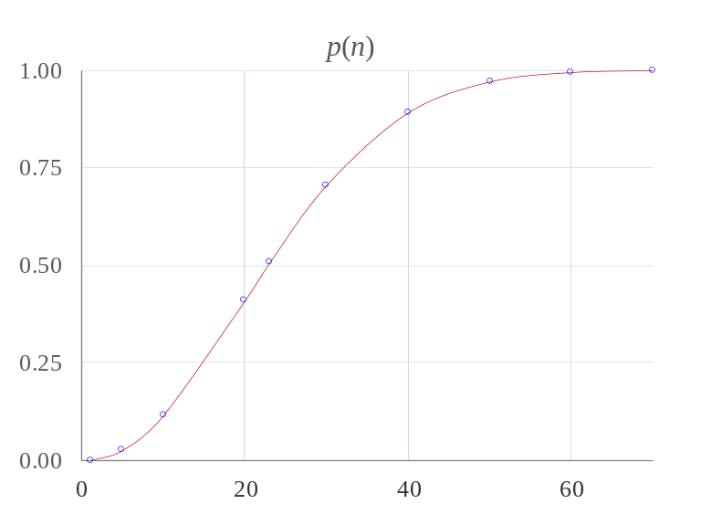
Figure 1. A probability of sharing a birthday among n persons.

A human logic will easily conclude that it is very unlikely for a group of 10 persons to have the same birthday.

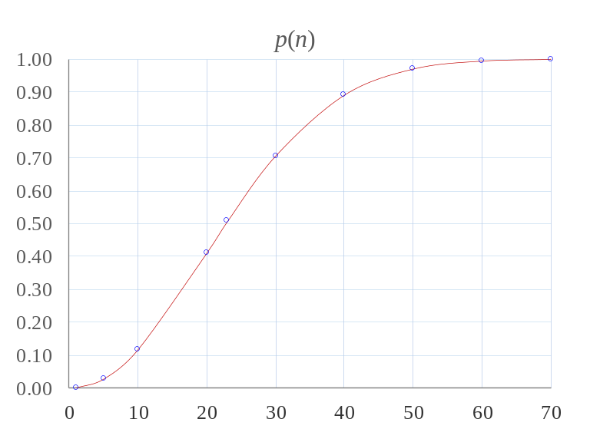
Figure 2. A probability of sharing birthday among n persons in sharper grid.

Partly, the main lesson, human mind is logical, psychological, theoretical, theological passion. Give THREE(3) theoretical lessons we can get from the graph above.
At n=10, theoretically, the probability to share a birthday is around 12%. In real life, a real number is near 15%.
At n=20, theoretically, the probability to share a birthday is just slightly higher than 40%. In real life, a real number is above 50%.
At n=30, theoretically, the probability to share a birthday is just slightly higher than 70%. In real life, a real number is above 80%.
In a block, last time such as DES, it takes slightly less than 50% of the keys to decrypt a ciphertext. In PKI especially RSA since 1980, in order to brute-force, how many instances or trials does it take to break RSA? The answer is just few percent. Security level today is around 128 bits taking a lesson from AES. If we take a discount of 8 bits, then we need to brute force around 120 bits.

In general, a public key infrastructure(PKI) cryptosystem is operating on at least 2 domain rings. For instance, RSA operates publically on a ring modulo N. At the same time, there are 2 more smaller private rings over prime P and Q fields. A ring modulo N is public and a ring modulo prime P is private. Getting an instance where 2 outputs collide in private rings means that the RSA modulo N can be factored.

However, a popular ECC is not operating in this private-public ring mode. It follows a one way function. A difficult problem in ECC relies on an EC discrete logarithm.

On one hand, RSA is operating on integers. On the other hand, there are 2 ECC modes. An ECC over prime P field and another operates on finite field over an irreducible polynomial. Next, NTRU will make use of polynomial prowes. NTRU operates on a smaller rings mod a small p=3 and a slightly larger relatively prime q=256. NTRU follows the same principle as of RSA.

Initial Plaintext
H⁰
SHA256
“Encryption” Engine
Final Ciphertext
H^{N}
Order
Message
Preset
Keys

Figure 3: A hash function as a block cipher.

Refer to Figure 3, give THREE(3) steps to represent a hash function such as SHA2 as a block cipher.

The SHA-256 compression function operates on a 512-bit message block and a 256-bit intermediate hash value. It is essentially a 256-bit block cipher algorithm which encrypts the intermediate hash value using the message block as key.

As a block cipher, the plaintext is the 8 registers a, b, c, d, e, f, g and h taken from fractional bits of the square root of the first 8 primes. The round keys to the block cipher are coming from the message and fractional bits of the cube root of the first 64 primes. The ciphertext coming out of the 64 rounds will be the message digest as the hashed value.

